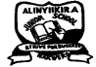 **ALINYIIKIRA JUNIOR SCHOOL - NAKWERO**

**BEGINNNING OF TERM III EXAMINATIONS 2024**

**AGE GROUP: 3 – 4 YEARS**

**CLASS: BABY**

**SUBJECT: SOCIAL DEVELOPMENT (LA 1)**

NAME:……………………………………………………………………..……

1. **a)What is the name of your school?**

b) Who is your class teacher?

c) In which class are you?

d) A cow says ________

A dog says ________

**e) Tell the pictures.**

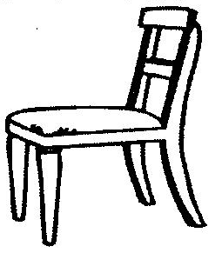  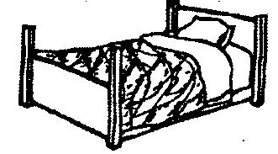



1. **Copy the word.**

t e a c h e r

1. **Circle the given picture.**

|  |  |
| --- | --- |
|  |  |
|  |  |
|  |  |
|  |  |

1. **Match and draw things in class.**

 

 

 